|  |  |  |
| --- | --- | --- |
| Average | | |
| Input | Process | Output |
| Put in 10 grade | Add the grades together and then divide them to get the average | Put out the average of the grades |

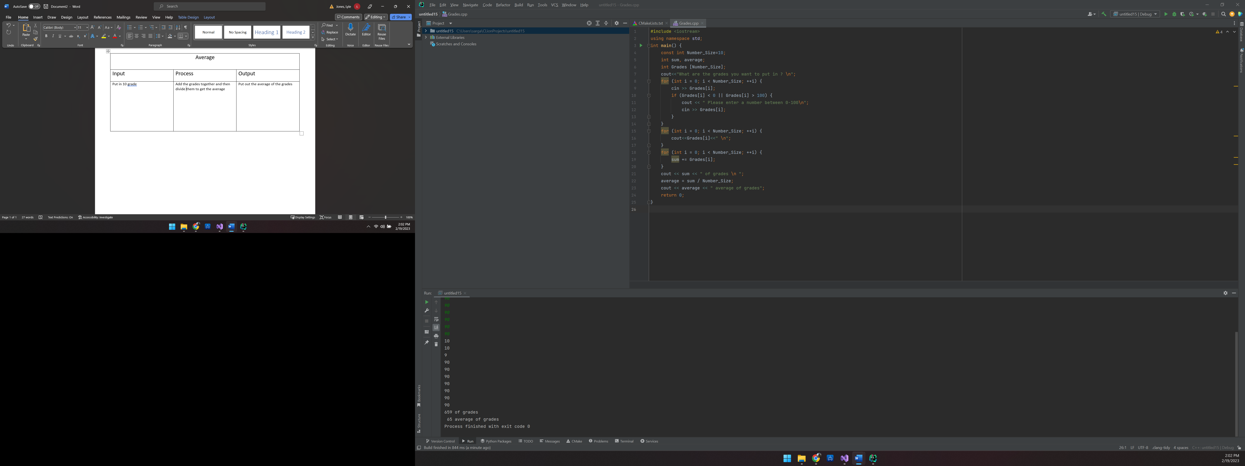

C:\Users\sarga\CLionProjects\untitled15\cmake-build-debug\untitled15.exe

What are the grades you want to put in ?

10

10

9

90

90

90

90

90

90

90

10

10

9

90

90

90

90

90

90

90

659 of grades

65 average of grades

Process finished with exit code 0

#include <iostream>  
using namespace std;  
int main() {  
 const int Number_Size=10;  
 int sum, average;  
 int Grades [Number_Size];  
 cout<<"What are the grades you want to put in ? \n";  
 for (int i = 0; i < Number_Size; ++i) {  
 cin >> Grades[i];  
 if (Grades[i] < 0 || Grades[i] > 100) {  
 cout << " Please enter a number between 0-100\n";  
 cin >> Grades[i];  
 }  
 }  
 for (int i = 0; i < Number_Size; ++i) {  
 cout<<Grades[i]<<" \n";  
 }  
 for (int i = 0; i < Number_Size; ++i) {  
 sum += Grades[i];  
 }  
 cout << sum << " of grades \n ";  
 average = sum / Number_Size;  
 cout << average << " average of grades";  
 return 0;  
}

|  |  |  |
| --- | --- | --- |
| Sort | | |
| Input | Process | Output |
| Put in 10 grade | Add the grades together and then divide them to get the average | Put out the average of the grades |

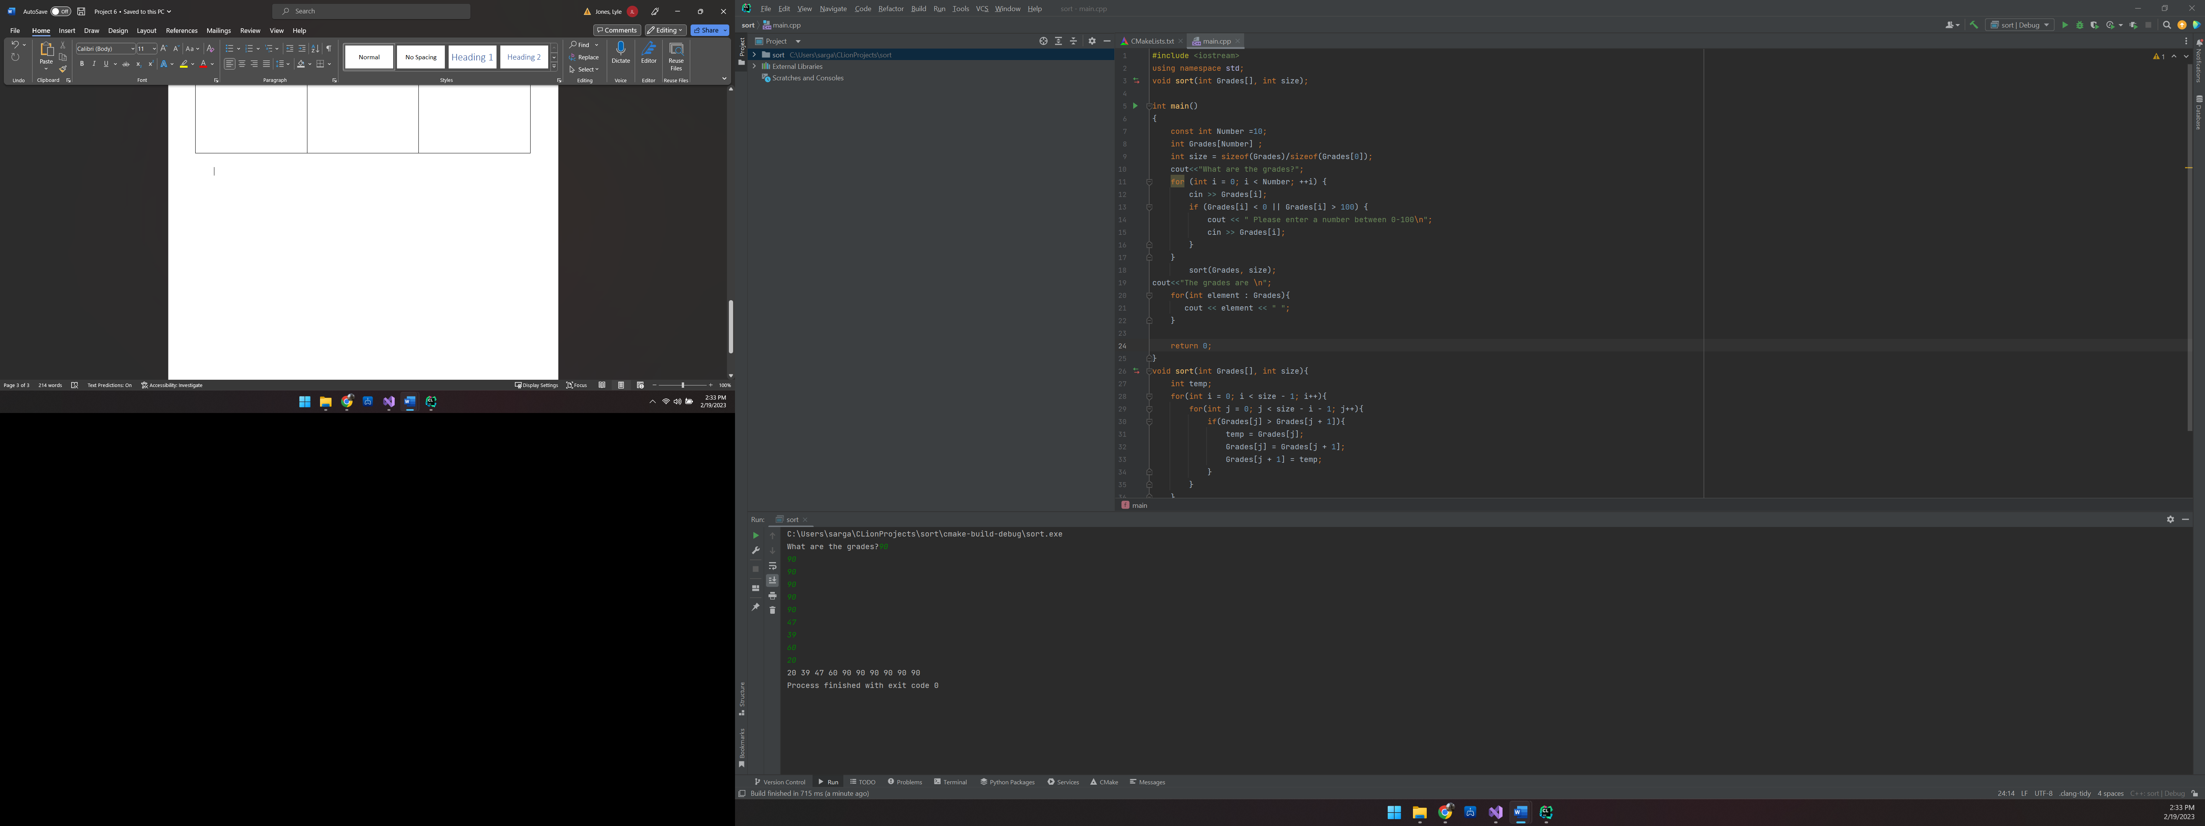

C:\Users\sarga\CLionProjects\sort\cmake-build-debug\sort.exe

What are the grades?90

90

90

90

90

90

47

39

60

20

20 39 47 60 90 90 90 90 90 90

Process finished with exit code 0

#include <iostream>  
using namespace std;  
void sort(int Grades[], int size);  
  
int main()  
{  
 const int Number =10;  
 int Grades[Number] ;  
 int size = sizeof(Grades)/sizeof(Grades[0]);  
 cout<<"What are the grades?";  
 for (int i = 0; i < Number; ++i) {  
 cin >> Grades[i];  
 if (Grades[i] < 0 || Grades[i] > 100) {  
 cout << " Please enter a number between 0-100\n";  
 cin >> Grades[i];  
 }  
 }  
 sort(Grades, size);  
cout<<"The grades are \n";  
 for(int element : Grades){  
 cout << element << " ";  
 }  
  
 return 0;  
}  
void sort(int Grades[], int size){  
 int temp;  
 for(int i = 0; i < size - 1; i++){  
 for(int j = 0; j < size - i - 1; j++){  
 if(Grades[j] > Grades[j + 1]){  
 temp = Grades[j];  
 Grades[j] = Grades[j + 1];  
 Grades[j + 1] = temp;  
 }  
 }  
 }  
}

|  |  |  |
| --- | --- | --- |
| Grader | | |
| Input | Process | Output |
| Put in 10 grade | Add the grades together and then divide them to get the average | Put out the average of the grades |

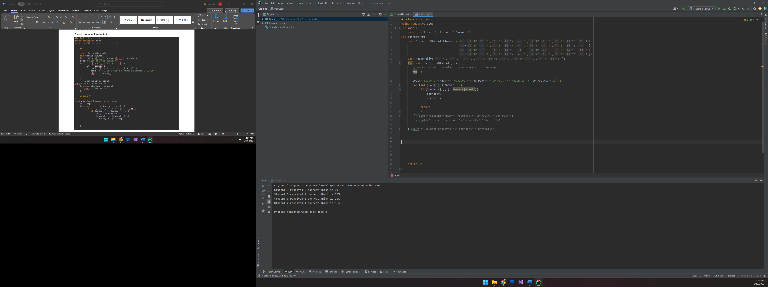

C:\Users\sarga\CLionProjects\Grading\cmake-build-debug\Grading.exe

Student 1 received 0 correct Which is 0%

Student 2 received 1 correct Which is 10%

Student 3 received 1 correct Which is 10%

Student 4 received 1 correct Which is 10%

Process finished with exit code 0

#include <iostream>  
using namespace std;  
int main() {  
 const int Size1=10, Student=4,Answer=10;  
int correct,num;  
 char Students[Student][Answer]={{'D','C','B','A','E','D','C','E','E','A'},  
 {'D','A','B','D','C','C','D','E','E','A'},  
 {'D','B','B','E','C','C','D','E','E','A'},  
 {'D','B','B','A','C','C','D','E','E','A'}};  
 char Answers[]={ 'A', 'D' ,'D','B','D','C','C','D','A','E' };  
 for (int i = 0; i <Student ; ++i) {  
 //cout<<" Student received "<< correct<< " Correct\n";  
 num++;  
  
 cout<<"Student "<<num<<" received "<< correct<< " correct"<<" Which is "<< correct*10<<"%\n";  
 for (int j = 0; j < Answer; ++j) {  
 if (Students[i][j]==Answers[Size1]){  
 correct=0;  
 correct++;  
  
 break;  
 }  
 }//cout<<"Student"<<num<<" received"<< correct<< " correct\n";  
 // cout<<" Student received "<< correct<< " Correct\n";  
   
 }//cout<<" Student received "<< correct<< " Correct\n";  
  
  
  
  
  
  
  
 return 0;